**D_10St. Francis Institute of Technology, Mumbai-400 103**

**Department of Information Technology**

**A.Y. 2024-2025**

**Class: TE-ITA/B, Semester: VI**

**Subject: MAD & PWA LAB**

**Experiment – 10: Deployment of a PWA to GitHub Pages as a free SSL enabled static app hosting solution**

1. **Aim**: To study and implement deployment of Ecommerce PWA to GitHub Pages.

2. **Objectives**: After study of this experiment, the student will be able to

● Test and Deploy PWA.

3. **Outcomes**: After study of this experiment, the student will be able to

● Analyse PWA Features and deploy it over app hosting solutions

4. **Prerequisite**: Github Account

5. **Requirements**: Visual Studio Code, Internet Connection, GitHub

**6. Pre-Experiment Exercise:**

Brief Theory:

● Before beginning to use GitHub Pages, you need two things:

1. Static web content that you want to host.

2. A GitHub repository to store the static web content that you would like to share. ● Serve the static content from the root folder of a specific branch. This branch is typically named gh-pages by convention.

● To check your project's configuration: Go to your GitHub repository, click on the settings tab, and scroll down to the GitHub Pages section. The branch should be configured to gh-pages and the folder set to / (root).

● After GitHub Actions has finished executing, it may take a few minutes for your content to be publicly visible. Wait a few minutes and then navigate to the URL: https://{username}. github.io/{repositoryname}.

**7. Laboratory Exercise**

A. Result/Observation

1. Screenshots of your PWA pushed on Git Hub

**8. Post-Experimental Exercise**

**A. Questions:**

1. Write the detailed steps to host a PWA to Github pages.

**B. Conclusion:**

1. Write what you have learnt in the experiment.

**C. References:**

1. https://www.pluralsight.com/guides/how-to-host-your-static-webpages-on-github pages

2. Building Progressive Web Apps, O’Reilly 2017.

Create a repository:

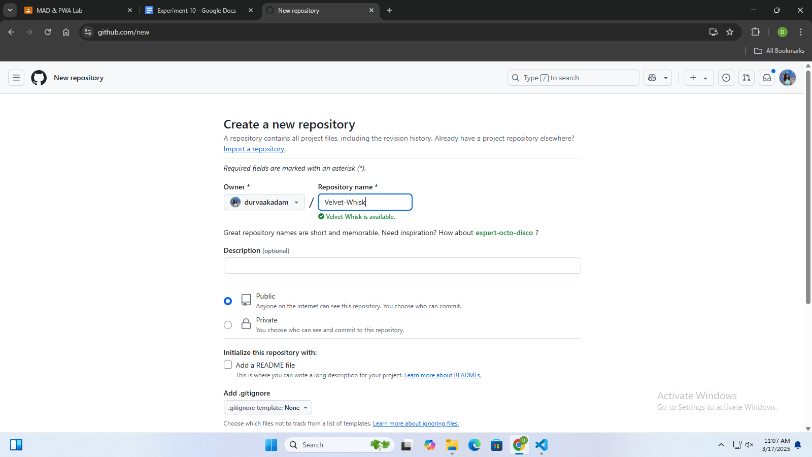

Push to Github: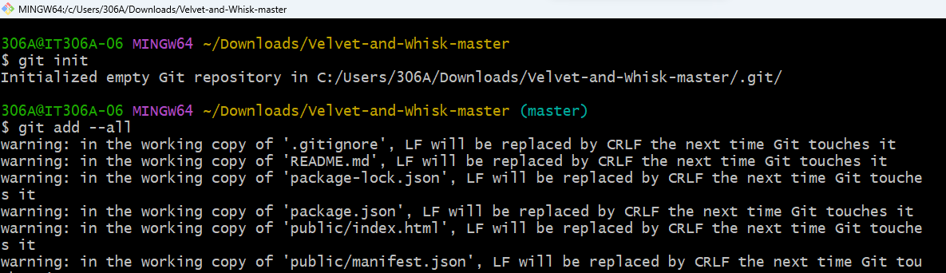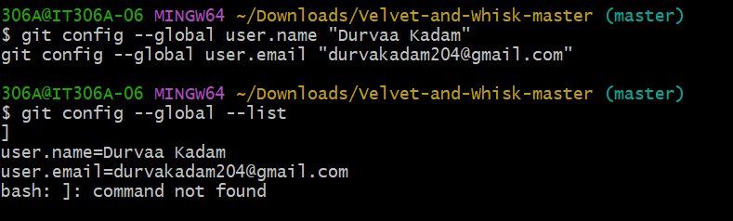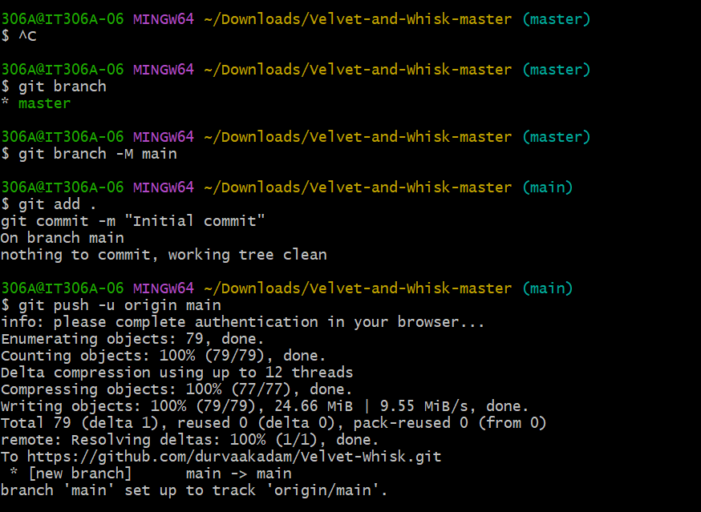

Repository visible on Github:

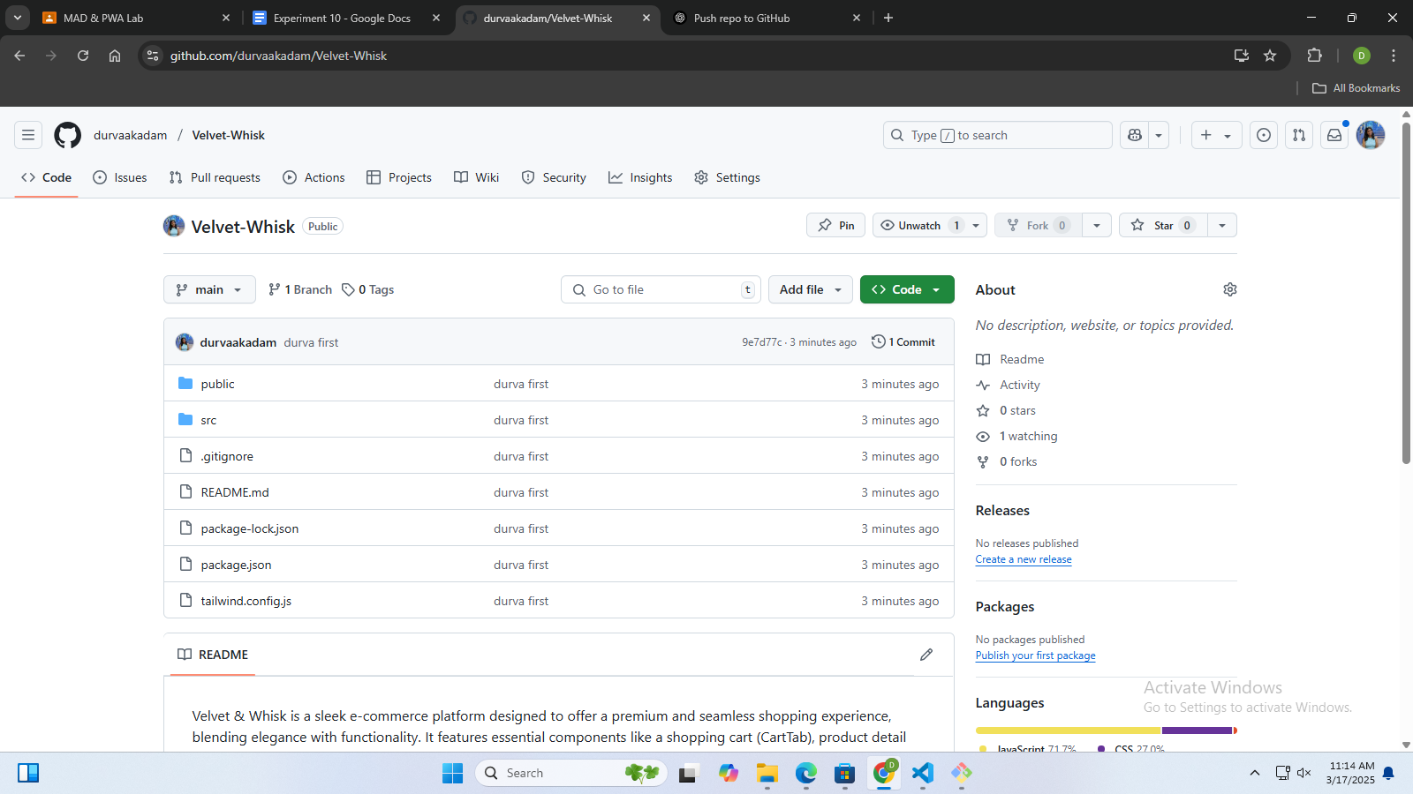

Static page deployment: 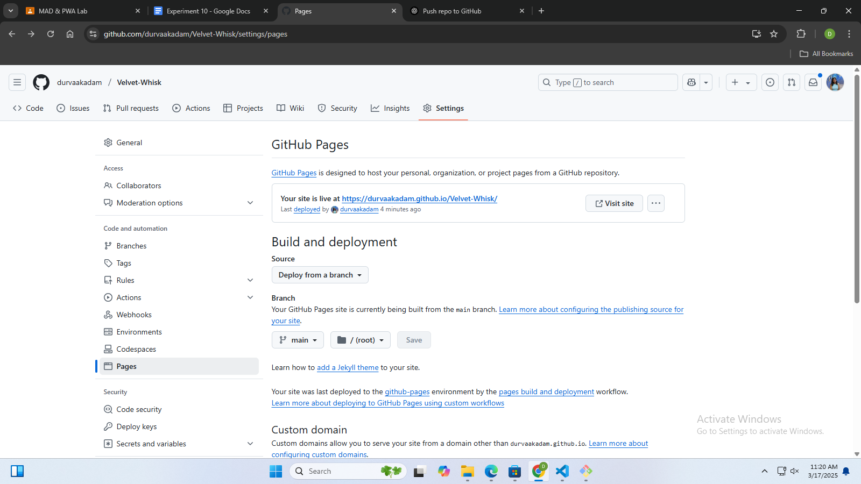

Site deployed on <https://github.com/durvaakadam/Velvet-Whisk>

